ACLU of West Virginia Foundation
2017 William Denman Youth Activist
Scholarship Application

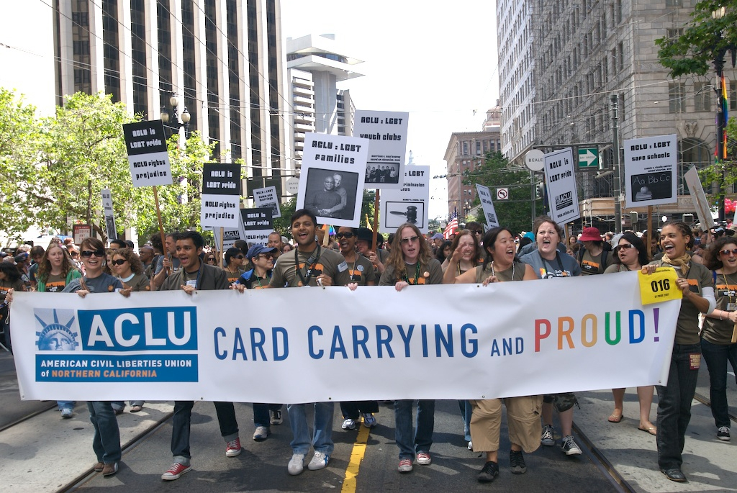

For additional information:

Joseph Cohen
ACLU of WV Foundation
PO Box 3952
Charleston WV 25339-3952
(304) 345-9246
mail@acluwv.org

ACLU of WV Foundation
William Denman Youth Activist Scholarship Application

- PERSONAL INFORMATION (to be completed by applicant)

First Name: ____________________ M.I.____ Last Name: ____________________

Address: _______________________________________________________________

City: _____________________ State: _________________ Zip: _____________

Phone: ____________________________ E-mail: ___________________________

High School: ____________________________________________________________

GPA: _____ (Please attach your latest high school transcript in a sealed envelope.)

How did you learn about the ACLU of WV Foundation Youth Scholarship Program?

________________________________________________________________________

________________________________________________________________________

Applicants: I agree to the rules of the ACLU of WV Foundation scholarship process. I affirm that the information enclosed in the application is accurate and original to me, and I authorize the ACLU of WV Foundation to reproduce, distribute, create derivative works of and publicly display my essay in all media now known or hereafter developed in connection with its mission, including for promotional purposes. If I am a recipient of an ACLU of WV Foundation Youth Activist Scholarship, I grant the ACLU of WV Foundation the right to use my name, likeness, and biographical information in all media in connection with ACLU of WV Foundation's mission, including promotional materials without any further compensation or permission.

Signature: ________________________________ Date: _____________________

For applicants under 18: Consent from a Parent or Legal Guardian is also required

I, ______________________, represent that I am the [parent/guardian] of the above named individual. I have read the foregoing and fully understand the contents hereof. I hereby consent to the foregoing on his/her behalf.

Signature: ________________________________ Date: ___________________

- ESSAY

On separate pages, please attach a personal statement of 1,000 words or less describing your civil liberties activism. Please include your understanding of what it means to be a civil liberties activist, specific examples of how you demonstrated your dedication to civil liberties, challenges you overcame, and how you showed leadership.

- RECOMMENDATION INFORMATION

Please select a teacher, counselor, or individual associated with an organization you are involved with to serve as your reference and have him/her complete this section. (Please do not use a family member.)

- In what capacity and how long have you known the applicant?

- How has the applicant shown his/her commitment and activism to civil liberties? Please provide specific examples.

- How has the applicant shown leadership and teamwork in his/her community, both through his/her activism and otherwise. Please provide specific examples.

- How do you see the applicant continuing his/her civil liberties activism in college?

5. Additional comments:

Name: __________________________ Title/Position________________________

School: ________________________________________________________________

Phone: _______________________ E-mail: ________________________________

Signature: _________________________________ Date: _________________

Please mail this completed application form with essay and transcript attached to:

Joseph Cohen, ACLU of WV Foundation, PO Box 3952, Charleston WV 25339-3952

