Here are some resources to help you get organized using Office 365 resources and Microsoft Teams. There are so many options within these platforms. Don’t try to learn every piece at once. Pick one to learn, watch the videos, take some notes and think how you can use for your class. Then once you get some comfort with it, move on to the next piece. You can expand on these and dive deeper once you get the basic understanding of these beginning pieces.
Office 365 Part 1: Finding Teams
Directions for logging in:
1. Go to office.com OR Marshall County Staff Link page & log into your school email account.
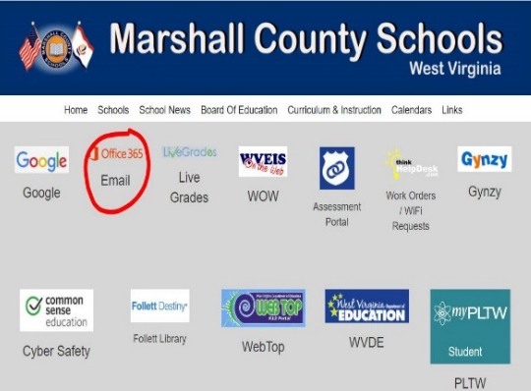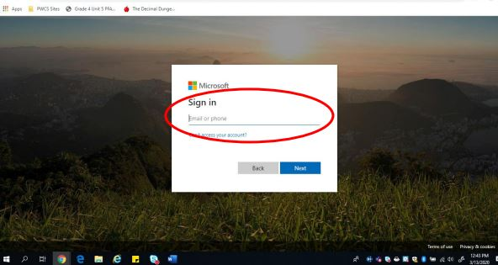
2. Make sure there is no other account already listed, if so, switch or forget accounts
3. A welcome message will pop up and then you click on teams to begin.
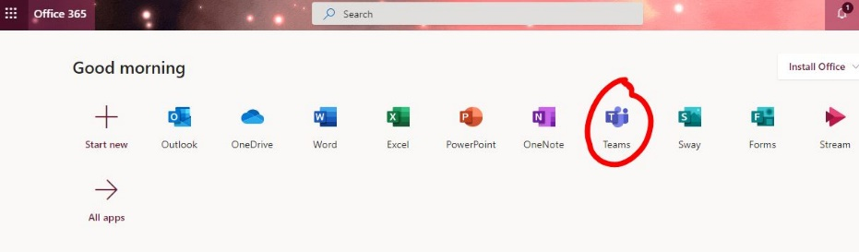
If Teams isn’t showing on this list for you, click on “All apps” to show more.
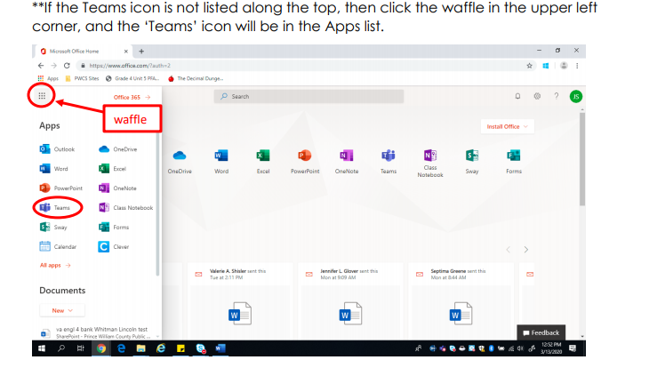
4. I don’t have a laptop. How will I access Teams? Look for the Teams App in the App Store on your mobile device. Log in using your work email. It is also in ‘Self Service’ on our schools IPADS. This step is also where you find OneNote, Word, OneDrive, and others.
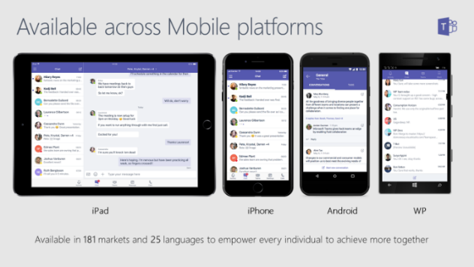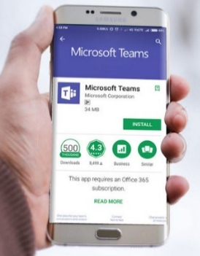
5. The state will make your class Team for your homeroom. All of your kids will already be rostered. YOU DO NOT NEED TO MAKE YOUR OWN CLASS. It will update nightly which will help you if you have kids moving in and out due to illnesses, virtual learning, moving from school to school, etc. However, you can make a practice class and start learning what you want to use, and how you want to set it up. When ready, begin your notebook in TEAMS. It is important that you do NOT start your notebook in the OneNote App. Go to the TEAM and then click on Class Notebook. From there you will follow directions to set up your OneNote Notebook.
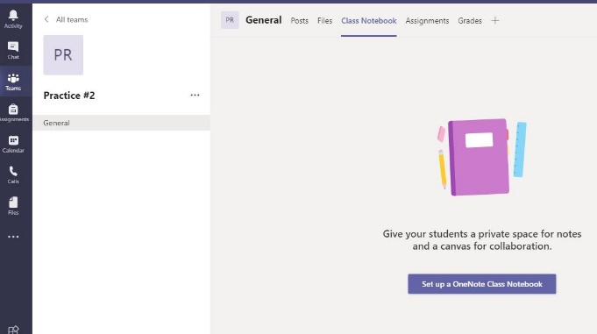
Office 365 Part 2: Word & OneDrive
Check when complete | Activity & Time | Link | Explanation
 | Microsoft Word: Tell Me Feature (1:57 + reading) | Do things quickly with Tell Me in Word | This is a text field where you can enter words and phrases about what you want to do next and quickly get to features you want to use or actions you want to perform.
 | Microsoft Word: Sharing Files (0:56) | Share a Document in Word | Do you have files you want to work on with your grade level team? You can share and work on the same document.
 | Finding Your Way in OneDrive (:54) | https://youtu.be/u-jzpNk0GiU | This is how to access files from anywhere
 | OneDrive video training. (1:25 + extras if you choose) | Uploading files and folders | How to upload, drag, rename etc.using OneDrive
 | OneDrive (5:11) | https://web.microsoftstream.com/video/8bd2871c-31ac-48fc-81b1-abe60bb7cc74 | How do you access work files from home? Video made by MCS Daniel Gatts
 | Immersive Reader  in Word (1:11) | https://youtu.be/8YvreWzOJss | This tool will read text to students. It can be found in many Office Apps.
 | Immersive Reader for Office Lens (4:10) | Office Lens and Immersive Reader | Office Lens will take pictures of a worksheet and read it to a student.
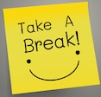

Part 3: Teams
Microsoft Teams- Microsoft Teams is a digital hub that brings conversations, content, assignments, and apps together in one place, letting teachers create vibrant learning environments. Build collaborative classrooms, connect in professional learning communities, and connect with colleagues—all from a single experience.
Check when complete | Activity & Time | Link | Explanation
 | Teams Basics (PDF + 4:17) | https://support.microsoft.com/en-us/office/downloadable-guides-6bd3eb82-0a0f-43cc-a4d2-c9f4e7ebdf39#ID0EDBAAA=Students  (Quick Start Guide for Teams, PDF)  https://web.microsoftstream.com/video/ebdf8763-6f31-454d-bf2c-66e41b2251fe (Mark Moore from WVDE Teams for beginners video) | If you’re a beginner, watch/read these first.
 | Teams Detailed (1 Hour 25mins) | https://web.microsoftstream.com/video/a46fb780-d09c-4194-bb62-57d314f948ae (Mark Moore detailed training on Teams. A step by step guide for virtual learning.)  Teams 2020 Quick Reference Guide PDF
 | Teams Assignments (5:00) | https://web.microsoftstream.com/video/6524e4d7-7163-4944-9bdf-9baea3077fb0 (Creating and grading Assignments in Teams, Mark Moore WVDE) | How to assign and grade work.
 | Teams- Looking from the Kids’ Perspective (9:00) | https://www.youtube.com/watch?v=SemjM2fHV2Q | This is a middle school teacher. Content will vary from Elementary. It does however show what the kids can access.
 | Creating a Bitmoji Classroom Homepage | Classroom Homepage Powerpoint | Add a homepage to your teams (PowerPoint made by MCS Employee Sarah Rouhier)
 | Bitmoji Homerooms (18:30 + Youtube 11:32) | https://cloud.swivl.com/v/6325d938c2f454196fd506d7f49fbb96?fbclid=IwAR088EVUNBeC3a5H4FrAL3JFRCuPOheyvLc0-uLv2--yY40JzHmjKqbaW30 (MCS Employee Brianna Cecil Video Tutorial on how to make a Bitmoji Interactive Classroom)  https://www.youtube.com/watch?v=ZUDoniqrUmQ (YouTube 11:32 minutes) | This is a fun and helpful option for your students. The interactive elements allow them to click through to see assignments, documents, and websites.
 | Immersive Reader  in Teams (1:24) | https://www.youtube.com/watch?v=GIRVT4jiS9g
Part 4: OneNote
Check when complete | Activity & Time | Link | Explanation
 | OneNote  -You choose from 8 options to watch (1:22 + extras) | https://support.microsoft.com/en-us/office/onenote-video-training-1c983b65-42f6-42c1-ab61-235aae5d0115 | OneNote is an online binder that holds all of your materials in one place. Think of the binders on your bookshelf but digital! You can have separate tabs, upload PDFs that kids can write on offline, and so much more.
 | OneNote Basic Tasks 1:58 + reading) | https://support.microsoft.com/en-us/office/basic-tasks-in-onenote-for-windows-10-081573f8-2e8f-45e5-bf16-0900d4d3331f
 | Basic set up for OneNote class notebooks (6:34) | https://www.youtube.com/watch?v=zC6eKH7MZeQ | Watch these when you are ready to build your own notebook.
 | Class Notebook (9:29) | https://www.youtube.com/watch?v=_IBB1avh7V0 | Kindergarten Teachers Katie Felix & how she uses class notebook with her “littles”
 | OneNote Kindergarten Example (11:25) | OneNote Kindergarten notebook | An example of how another Kindergarten teacher organizes her notebook.

Part 5: Communication
Check when complete | Activity & Time | Link | Explanation
 | Remind (7:00 + Powerpoint) | https://www.youtube.com/watch?v=vRMrNE4eDCw  PDF presentation on Remind basics | Two-way communication for updates, instruction, and more—at every level in your school. Our county has purchased this for us.
 | Meet Now (0:50) | https://www.youtube.com/watch?v=rWIUIe-M9nw | If you need on the spot 1-on-1 time this is a great way to meet.
 | Teams Video Conferencing (4:25) | https://www.youtube.com/watch?v=WDU9ezNAipw  (These can be recorded and referred back to at a later time if needed. You can set a meeting in your Team to “Join Now” or set up a daily time to meet for morning meeting times, story time, times for kids to read to you, etc.) | This replaces Zoom. You can use this for small groups of students, whole groups, etc.
 | Setting Office Hours (6:00) | https://www.youtube.com/watch?v=bBhTW25umtY&feature=share | At the elementary level this would be good to set up 1 or 2 hours daily where you are available for families to reach out. If students do not have internet, they can call in using the number assigned to the meeting.

Part 6: Creating Instructional Videos & iPad Basics
Check when complete | Activity & Time | Link | Explanation
 | Stream (0:40) | https://web.microsoftstream.com/video/7b137320-7733-4054-b62e-c6d76e13c803 | Think of Stream as your company’s own YouTube® – a place to organize, store, and share videos. Unlike YouTube®, Stream is private to your organization and requires that the user log in/authenticate into the hub using Office 365 credentials. You can share these on your OneNote notebook and Team!
 |  | https://docs.microsoft.com/en-us/stream/portal-create-screen-recording Creating a Screen Recording directions on Microsoft.com
 | IPads | iPad Basics Power Point in PDF format. Full PPT with page links and embedded videos will be available for training purposes in your school.  Video Version of the PPT | This PowerPoint has videos to show you basic functions of iPads. Click on the arrow on the slide to begin each video. This was made by MCS employee Daniel Gatts.

Part 7: Feedback
Check when complete | Activity & Time | Link | Explanation
 | 10 Minutes | https://forms.office.com/Pages/ResponsePage.aspx?id=S7AZ4AwzekaLrgn7FzdNai68Ym1XugdHrlh89jnf0rVUNUkyRUQ5UVBQMkRPTkVXR1NOUVJXUFpZTS4u | Please provide feedback so we can continue to provide appropriate professional development.

